Dreame Bot D10 Plus Robot Vacuum and Mop
FAQ V1.0

Contents
Contents 1
● General 5
What is the Dreame D10 Plus Robot? 5
What does Dreame D10 Plus feature? 5
What is LDS laser navigation? 6
What is the advantage of the LDS laser navigation? 6
● Product Introduction and User Guide 7
What is the those buttons on the robot vacuum for, and how do I use it? 7
What is meaning of the status indicator in the Auto-Empty Base? 7
How to connect robot with Dreamehome or Mi Home App? 8
How to reset Wi-Fi with Dreame D10 Plus robot? 1
How to use the Spot Clean function with Dreame D10 Plus robot? 1
How to use the Do-Not-Disturb mode with D10 Plus? 2
How to use the scheduled clean-up feature with Dreame D10 Plus robot? 2
How to save a map with the Dreame D10 Plus robot? 2
How to use the Advanced Map function with the Dreame D10 Plus? 2
How does the D10 Plus clean up the entire house? 2
Can Dreame D10 Plus connect to the Base all the time? Is there overcharge protection? 3
What is the size of Dreame D10 Plus? 3
How long does it take to charge Dreame D10 Plus fully? 4
What battery does the Dreame D10 Plus use？ 4
What is the run-time of the robot vacuum? 4
Does Dreame D10 Plus have a motor overload protection? 4
Does Dreame D10 Plus have any consumables that require maintenance regularly? 4
● Installation and Maintenance 5
How to use the Auto-Empty Base? 5
How to charge the Dreame D10 Plus? 5
How to use the Mopping Function with Dreame D10 Plus? 6
How to remove the water tank with the Dreame D10 Plus? 7
How to start cleaning with the Dreame D10 Plus? 8
How does the Dreame D10 Plus return to the Base for charging? 8
How to clean the main brush of the Dreame D10 Plus? 8
How to clean the dust and filter of the Dreame D10 Plus? 9
How to clean the omnidirectional wheels of the Dreame D10 Plus? 10
How to clean the side brush of the Dreame D10 Plus? 11
How to clean the mop of the Dreame D10 Plus? 11
How to do the routine maintenance for the robot vacuum? 12
How to do the routine maintenance for the Auto-Empty Base? 13
How to replace the Dust Collection Bag 14
How to maintain the battery of Dreame D10 Plus? 15
How should I upgrade the firmware of D10 Plus? 16
How to restore to factory settings with Dreame D10 Plus? 16
● FAQs 16
How to deal with the Wi-Fi network configuration failure? 16
Why does the Dreame D10 Plus fail to charge? 17
What should I pay attention to before cleaning with Dreame D10 Plus? 17
Do I need to charge the D10 Plus for 16 hours for the first three tasks? 17
Why does the robot fail to squirt water or operate with little water during mopping? 17
What should I do if the top cover of the water tank leaks? 18
Do I need to update the firmware whenever there is a new version released? 18
Why does D10 Plus start to clean the next zone before finishing the current one? 18
Why does D10 Plus repeat its cleaning path? 18
Can Dreame D10 Plus clean narrow spaces? 18
Will the cleaning efficacy drop when cleaning a complicated environment? 18
How to reduce the noise during the cleaning? 19
Why does D10 Plus make strange sounds during cleaning? 19
What should I do if the Dreame D10 Plus is trapped during cleaning? 19
What should I do if the Dreame D10 Plus gets stuck when trying to pass through some house furnishings? 19
What should I do if the side brush or main brush is entangled during cleaning? 20
What should I do if the Dreame D10 Plus is entangled with the power cable of the Base? 20
Why does the Dreame D10 Plus fail to relocate itself? 20
What is the max height of obstacles D10 Plus can cross? 20
Why does D10 Plus fail to decelerate when meeting the obstacles? 20
How to deal with device errors of the Dreame D10 Plus? 21
Why does D10 Plus fail to power on? 21
Does D10 Plus consume any power when connected with the Base? 21
Why does the D10 Plus fail to return for charging? 21
Why does the robot keep connecting to the base after returning to charge? 22
Why couldn’t I open the dust bin? 22
How to mop those stubborn stains on the floor? 22
Why is the floor still dirty after mopping? 22
Why do I fail to install the mop pad properly? 22
Why do I smell the odor from the mop and dust compartment? 22
Why does the D10 Plus fail to do schedule clean? 23
Why does D10 Plus fail to resume cleaning after recharging itself? 23
Why does the performance of D10 Plus fade with missed debris on the floor? 23
Can D10 Plus operate in the low-light environment? 23
Why does the D10 Plus fail to upgrade the firmware? 23
Why does Mi Home/Dreamehome App fail to load the cleaning data？ 23
How to prevent the robot vacuum from cleaning the carpet? 23
Why is the map different than before? What should I do if the map is distorted, inclined, or overlapped? 24
What should I do if the map configuration is not correct? 24
Why is the Carpet Boost function unstable? 24
What should I do if the robot vacuum fails to avoid obstacles during the cleaning? 25
Why does the D10 Plus use a single-sided brush instead of a double-sided brush? 25
Can I use D10 Plus to clean carpets? 26
What should I do if the Dreame D10 Plus gets stuck when trying to pass through a narrow space? 26
Why does D10 Plus fail to reposition itself？ 26
Why does the battery decrease rapidly during cleaning？ 26
Why does D10 Plus fail to return to the Base? 26
How to adjust the humidity of the mop pod？ 27
Why does the D10 Plus fail to avoid some obstacles？ 27
Why does the robot fail to react when operating from the base？ 27
Why does the robot turn off automatically？ 27
Why does Mi Home/Dreamehome App indicates that the robot is offline？ 27
Why does the robot make a strange noise？ 28

● General

What is the Dreame D10 Plus Robot?
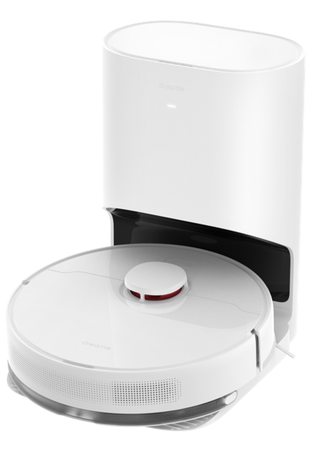
The Dreame D10 Plus Robot is a smart Robot vacuum and mop cleaner, which could handle both the sweeping and mopping simultaneously. And it could automatically return to the dock for charging after cleaning.The auto-empty system blow air into the robot’s dust box and it vacuum into a 2.5L dust bag. High-speed emptying, minimal noise, and virtually no clogging，making the house cleaning much more convenient.

What does Dreame D10 Plus feature?
· Automatic dust collection: Dual circulation air paths provides efficient dust collection via blowing and suction.
· Powerful suction:4,000Pa of suction pressure picks up dirt and debris from hard floors and carpet.
· Automatic suction adjustment: Boosts suction on carpet for deeper cleaning and conserves power on hard floors.
· High capacity bag: Holds 2.5L of dust for up to 45 days of daily cleaning before needing to be emptied.
· Upgraded anti-tangling roller brush: Improves cleaning capability by preventing hair and pet hair from tangling around the brush and interfering with cleaning the problem of pet hair.

What is LDS laser navigation?
LDS laser navigation technology measures the relative position of the boundary and the robot vacuum by emitting the invisible laser and receiving reflected light. Based on this, the robot’s position in the map is determined, and a complete cleaning map is built.
The Dreame D10 Plus is equipped with professional lidar sensors, which can scan up to 2,080 points per second with a scanning range of up to 8 m and an accuracy of 10 mm.

What is the advantage of the LDS laser navigation?
The LDS laser navigation is faster in creating the map and more precise in locating than the vSlam. It also supports more map operation options.

● Product Introduction and User Guide

What is the those buttons on the robot vacuum for, and how do I use it?
Please refer to the table below:
Function | Operation
Power/Clean  | · Press and hold for 3 seconds  · Press to begin cleaning after the robot is powered on
Dock/Spot Clean | · Press to send the robot back to the base  · Press and hold for 3 seconds to start Spot Clean Mode
Status Indicator | · White: Cleaning or cleanup is completed  · Blinking Orange: Error  · Breathing White: Robot is charging when the battery  power is not low

What is meaning of the status indicator in the Auto-Empty Base?
Please refer to the table below:
White: The base is plugged in
Breathing White: Robot is charging
Blinking Orange: Dust collection bag is full/Dust collection bag not installed/Error

How to connect robot with Dreamehome or Mi Home App?

1. Scan the QR code to download the Dreamehome or Mi Home App


2. Add Device
Mi Home/Xiaomi Home APP: Open the Mi Home/Xiaomi Home app, tap "
" in the upper right, and scan the QR code above again to add "Dreame Bot
D10 Plus". Please follow the prompts to finish the Wi-Fi connection.
Dreamehome APP: Open the Dreamehome app, tap " " in the upper right
to go to the "Add Device" page, and then select "Dreame Bot D10 Plus".
Please follow the prompts to finish the Wi-Fi connection.

3. Reset Wi-Fi
Simultaneously press and hold the buttons and until you hear a voice
prompt saying, “Waiting for the network configuration.” Once the Wi-Fi
indicator is blinking slowly, the Wi-Fi has been successfully reset.
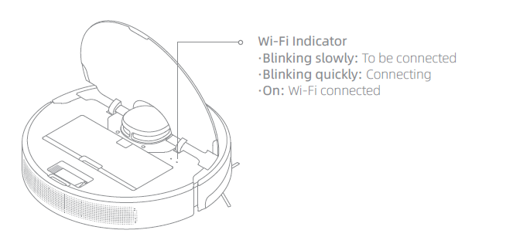
Note: If your robot cannot connect to the app successfully, reset the Wi-Fi and
add the device again.

How to reset Wi-Fi with Dreame D10 Plus robot?
Open the top cover and observe the Wi-Fi indicator LED. Then press and hold the Spot Clean button and Dock button until hearing a voice prompts of "waiting for network configuration.”
When the Wi-Fi indicator starts to flash slowly again, it means the Wi-Fi reset is successful.

How to use the Spot Clean function with Dreame D10 Plus robot?
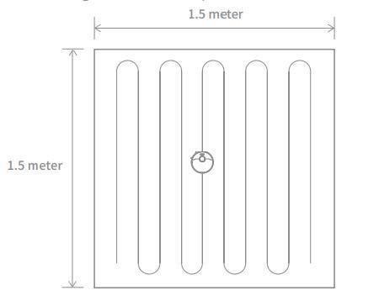
When the robot is paused or in Standby Mode, press and hold the button for 3 seconds to start Spot Clean Mode. In this mode, it will clean a square-shaped area of 1.5×1.5 meters directly around the robot. When the spot cleaning is done, the robot will automatically return to its original location and power off.
Note: Activating Spot Clean Mode will end the current cleaning task of the robot.

How to use the Do-Not-Disturb mode with D10 Plus?
DND mode is enabled by default from 10:00 pm to 08:00 am. You can disable or edit DND mode with the Mi Home or Dreamehome app. D10 Plus will stop cleaning and voice reporting during the DND period, and the power indicator is off.

How to use the scheduled clean-up feature with Dreame D10 Plus robot?
Users can set the schedule clean-up via the APP.
Then, the robot vacuum will automatically start cleaning at the scheduled time and return to the charging base once the cleaning is finished.

How to save a map with the Dreame D10 Plus robot?
When the robot is charging on the Base, launch the Mi Home app, tap to start cleaning, and D10 Plus will automatically learn about the surrounding environment and build up a complete map after several tasks. Please open all room doors during cleaning to keep the map consistent and complete.

How to use the Advanced Map function with the Dreame D10 Plus?
Launch the Mi Home app, tap to start cleaning, and D10 Plus will automatically learn about the surroundings and begin building a complete map, where you can access Auto Zone, Area Editor, Zoned Cleanup, Designated Cleanup, Virtual Wall, and other functions.

How does the D10 Plus clean up the entire house?
When started initially, the robot will clean along the edge of an area by 4.5*4.5m, then clean the inner part by S-shape path until covering this area. After the area is clean, it will clean all other rooms in your house by the same principle.
After generating the map, the robot will clean the rooms by the order which edge cleaning first, then S-shape path cleaning until covering all rooms. It is an efficient way to prevent any missed areas.After cleaning, it will return to the Base
automatically.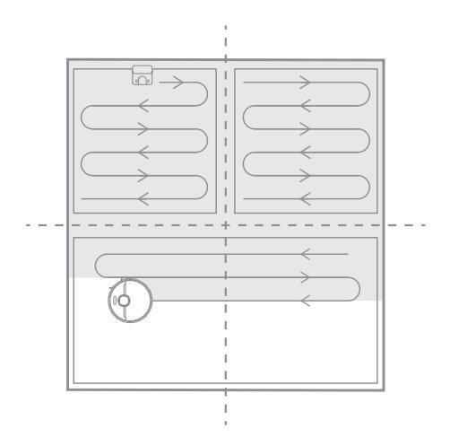

Can Dreame D10 Plus connect to the Base all the time? Is there overcharge protection?
Yes. The robot supports overcharging protection and will disconnect automatically once fully charged.

What is the size of Dreame D10 Plus?
The dimension of the Robot is 349*350*96.3 mm;
The dimension of the Auto-Empty Base is 303*403*399 mm.

How long does it take to charge Dreame D10 Plus fully?
It is about 5 hours

What battery does the Dreame D10 Plus use？
It is a 5200mAh high-performance Li-Po battery pack

What is the run-time of the robot vacuum?
The robot vacuum can operate about 170 minutes under the Standard mode and moist humidity of the mop pad. The actual result may vary due to different temperatures and tasks.

Does Dreame D10 Plus have a motor overload protection?
Yes. Dreame D10 Plus has overload protection for all motors on-board, including the suction module, main brush, side brush, and main driving wheel. Motor overload protection is on once the robot is severely clogged with debris or foreign matters.

Does Dreame D10 Plus have any consumables that require maintenance regularly?
Consumables | Suggested Maintenance
Main Brush | Clean weekly and replace every 6-12 months
Filter | Clean weekly and replace every 3-6 months
Side Brush | Clean weekly and replace every 3-6 months
Mop | Wash after the cleaning and replace every 3-6 months

● Installation and Maintenance

How to use the Auto-Empty Base?
Place the base on level ground against the wall and connect it to a power
outlet. Place the robot onto the base to charge. The robot will turn on
automatically and begin charging. It is recommended to fully charge your
robot before first-time use.
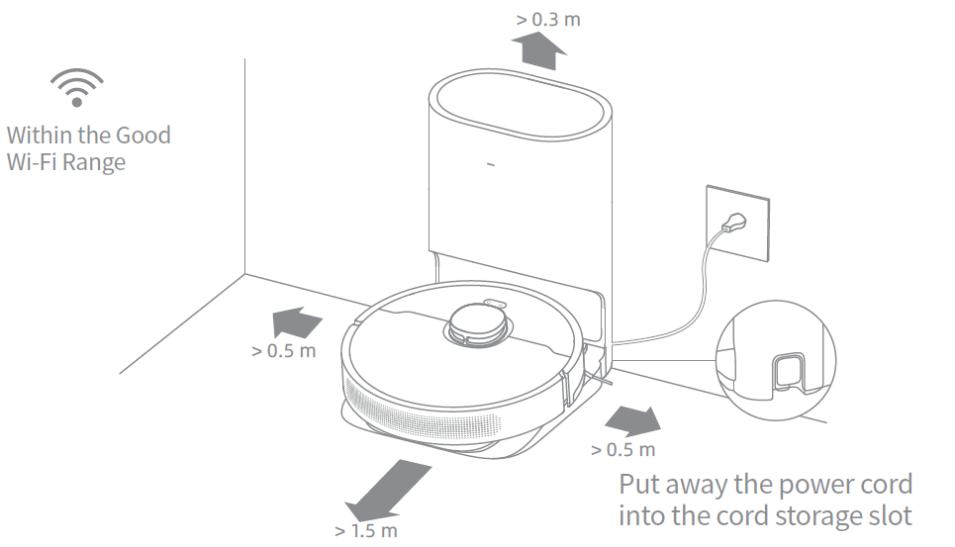
Note:
• Keep the immediate area 1.5 m in front of the base and 0.5 m to its both sides clear of objects.
• Make sure that no objects might block the signaling area.

How to charge the Dreame D10 Plus?
Press the power button and hold until the power indicator turns solid.
Then place the robot close to the Base, and it will start charging automatically.
Note: Dreame D10 Plus may fail to power on in low battery. Please place the Robot directly to the Base.

How to use the Mopping Function with Dreame D10 Plus?
It is recommended that all floors are vacuumed at least three times before the first mopping session to achieve a better cleaning effect.
1) Dampen the mop pad and wring out excess water. Insert the mop pad into the slot of the water tank as shown in the figure, and paste the pad firmly.
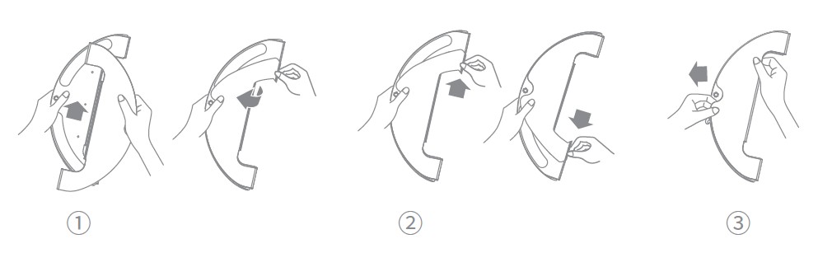
2) Open the water tank lid, fill the tank with water, then securely close the lid.
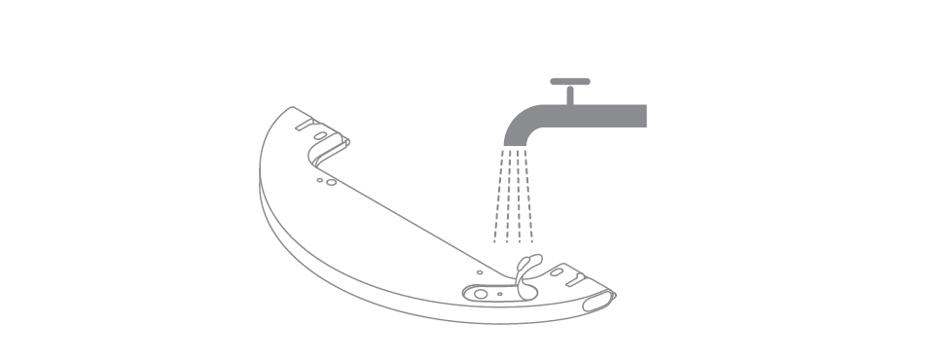
Note: Do not use detergent or disinfectant.
3) Align the mopping module as indicated by the arrow, then slide it into
the back of the robot until it clicks into place. Press the button or use the
Dreamehome or Mi Home/Xiaomi Home app to start cleaning.
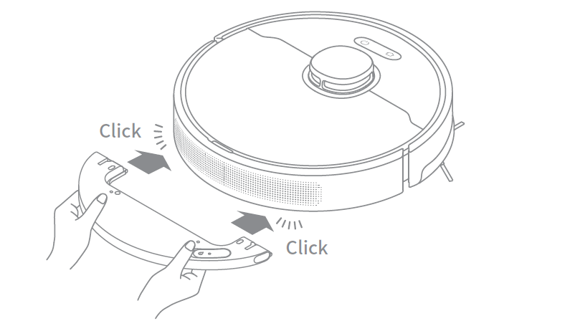
Note:
• It is not recommended to use the mopping function on carpets.
• Use the app to adjust the water flow as required.
4) Press the two side clips inwards and slide the water tank backwards to
separate it from the robot.
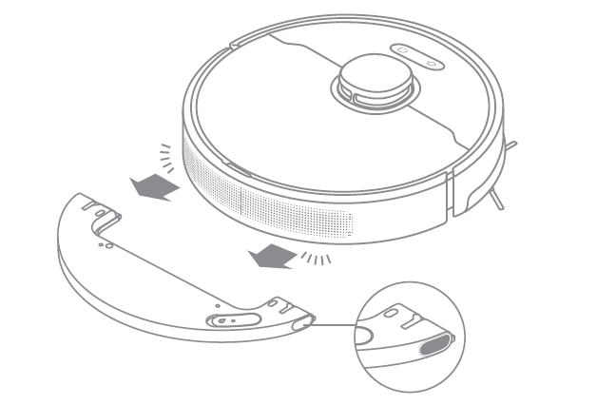
Note: When the robot is charging or not in use, remove the mopping module,
pour out all the remaining water in the tank, and clean the mop pad to prevent
mildew or odors.

How to remove the water tank with the Dreame D10 Plus?
Press the two side clips inwards and slide the water tank backward to separate it from the robot.

How to start cleaning with the Dreame D10 Plus?
Press the power button, it will start cleaning.
Press any button during the cleaning, and it will pause.
Note: Dreame D10 Plus will fail to work when the battery is too low. Please charge before using.
If the completed cleaning duration is less than 10 minutes, the Dreame D10 Plus will do the cleaning twice by default.

How does the Dreame D10 Plus return to the Base for charging?
After the cleaning, the Robot will return to the Base for charging automatically.
Press the Dock button when the Robot is under Pause status.
When the Robot is charging, the power button will flash in colors: battery>15% with White and battery <15% with Orange.

How to clean the main brush of the Dreame D10 Plus?
1. Face the bottom of D10 Plus up, press the buckle to remove the main brush protector.
2.Take out the main brush by pulling upward and clean the bearing.
Remove the end cover at both sides of the main brush to clean the tangled hair.
3.Cut off the tangled hair on the main brush with the cleaning tool in the box.
4.Install the main brush and press the buckles to fix the protector.
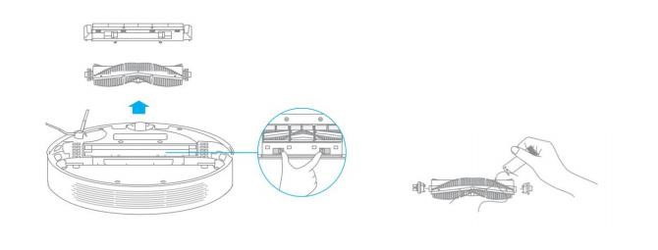
Note: It is recommended to clean the main brush every week and replace it every 6-12 months for better cleaning performance.

How to clean the dust and filter of the Dreame D10 Plus?
A:（1）Open the upper cover of the robot, press the buckle to remove the dust bin;
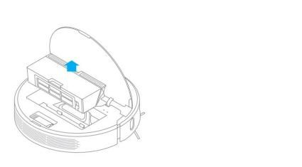
Open the bin cover marked with the arrow and remove the debris inside;
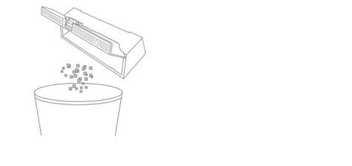
Fill th dust bin with water, close the cover, shake the bin left and right, pour out, and repeat for several times;
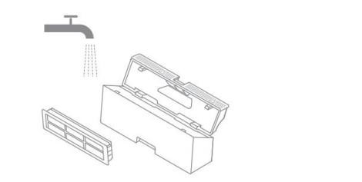
Note: Wash the dust bin with water only. Do not add any detergent or clean the filter screen with a finger or brush.
Remove the filter screen as illustrated, spin off the water, dry the filter before installing it back to the bin for use.

Note: Ensure the filter is dried up (for at least 24 hours) before use.

How to clean the omnidirectional wheels of the Dreame D10 Plus?
1.Turn the robot over and pull the wheels upward.
2.Clean the hair and dirt on the wheels and axles.
3.Re-install the wheels by pressing them firmly down.
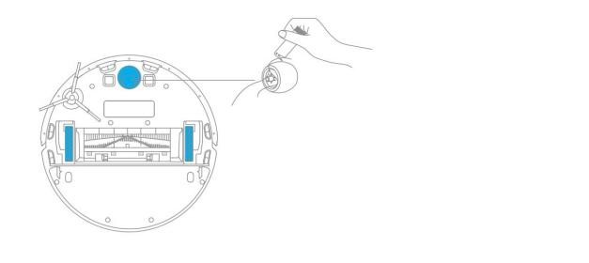
Note: Wheels can be rinsed with running water. Make sure to dry up before use.

How to clean the side brush of the Dreame D10 Plus?
1. Turn over the robot, pull out the side brush and clean it up as shown below.
2.Re-install the side brush.
Tip: It is recommended to clean the side brush once a month and replace it every 3-6 months for better clean performance.
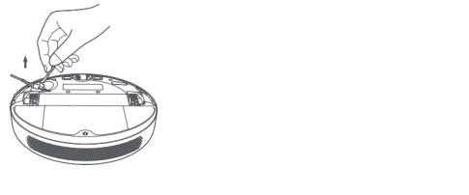

How to clean the mop of the Dreame D10 Plus?
1. Press the two release clips on the side of the water tank, remove the
mopping module, and pull the mop pad off the mopping module.
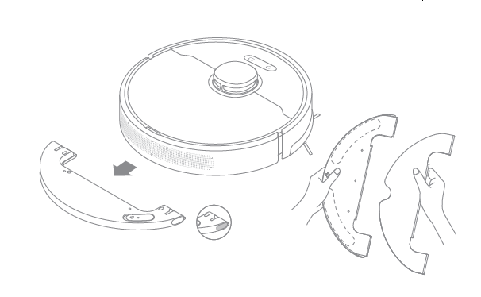
2. Pour out the water in the tank. Clean with only water and leave out to air dry before re-installing.

Note: Do not expose the tank to the sun directly.
3. Clean the mop pad with water only and leave to air dry before re-installing.
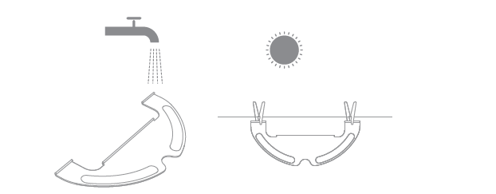
Note:
• Remove the pad from the mopping module before cleaning it, and make sure
dirty water does not flow back into the water outlet to avoid clogging.
• For optimal performance, it is recommended to replace the mop pad every 3-6
months.
4. If slow water flow occurs, or the volume is not well-distributed, clean the air hole in the cover of the water tank.


How to do the routine maintenance for the robot vacuum?
Use soft dry cloth to wipe the parts, which includes:
1.Four cliff sensors at the bottom
2.The infrared deceleration sensor in the front
3.The electric pole at the bottom
4.Motion tracking sensor at the bottom
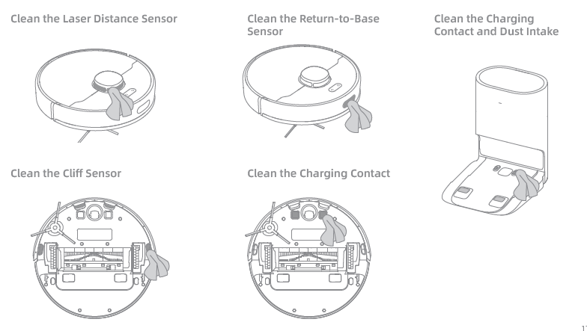

How to do the routine maintenance for the Auto-Empty Base?
Clean the Air Duct
If the air duct is blocked, please clean it according to the following steps.
1. Unscrew mounting screws on the air duct cover and remove the cover plate.
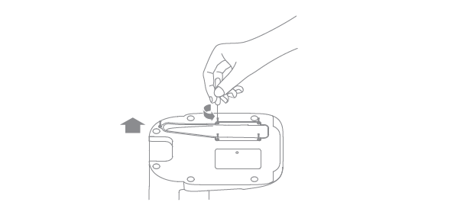
2. Check whether the air duct is blocked by foreign objects. If any, clean them.
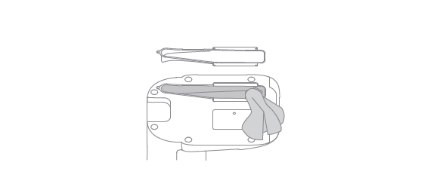
3. Reinstall the air duct cover as shown in the diagram.
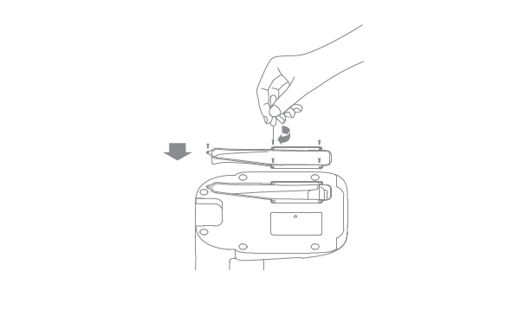

How to replace the Dust Collection Bag
According to the status indicator (blinking orange) and app prompts, replace it with a new one when the dust collection bag is full. It is recommended to replace the bag every 4-6 weeks.
- Discard the dust collection bag
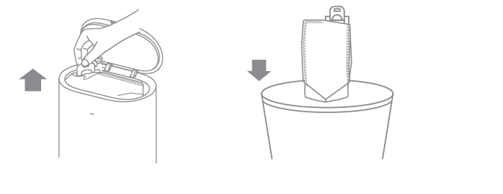
Note: When taking out the dust collection bag, close the dust bag handle to avoid dust leaking out.
2. Wipe the filter with a dry cloth
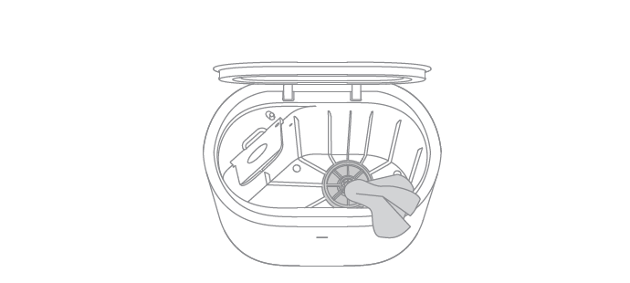
3. Install a new dust collection bag
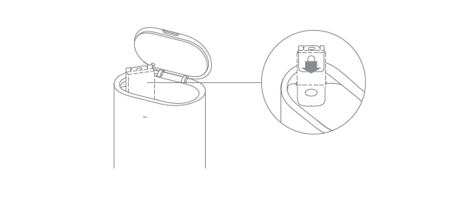
4. Close the upper cover of auto-empty base
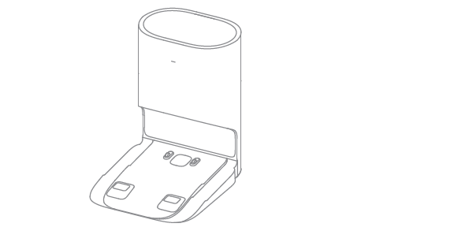
Note: Do not close the base forcelly, if the upper cover of base cannot be
closed and the dust collection bag is not installed.

How to maintain the battery of Dreame D10 Plus?
The robot contains a high-performance lithium-ion battery pack. Please
ensure that it remains well-charged for daily use to maintain optimal
battery performance. If the robot is not used for an extended period of
time, turn it off and put it away. To prevent damage from over-discharging,the robot should be recharged at least once every three months.

How should I upgrade the firmware of D10 Plus?
It can be done by Mi Home or Dreamehome APP(please make sure the D10 Plus is on the Base and the battery is over 15%).
Two buttons on the D10 Plus will flash rapidly during the Whole process.

How to restore to factory settings with Dreame D10 Plus?
A: If D10 Plus still fails to operate normally after restarting, press and hold the reset button with a tool until hearing the voice prompt “start to restore factory settings.”
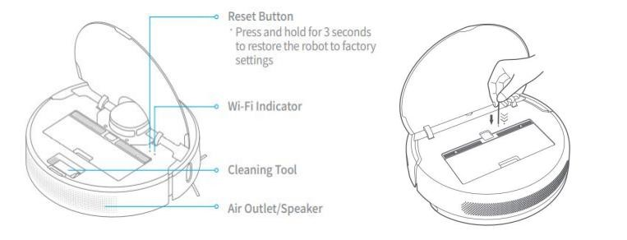

● FAQs

How to deal with the Wi-Fi network configuration failure?
The Dreame D10 Plus only supports the 2.4G Wi-Fi network. It could not work with the 5G Wi-Fi network. Please check below:
1.Confirm both the Robot and the mobile phone are close to the Wi-Fi router with strong Wi-Fi signals.
2.When connecting to the Hotspot of the Dreame D10 Plus, please kindly return to the
app to wait for the configuration result until hearing the voice prompt.
3.Enable the Location permission settings for the App. If not, the connection will fail.
4.If the configuration still fails, please reboot the router and the robot.
For further assistance required, please kindly contact the Dreame Support Team.

Why does the Dreame D10 Plus fail to charge?
Please clean the charging interface of the Base and the robot if there is any dust on it, as dust may result in charging failure.

What should I pay attention to before cleaning with Dreame D10 Plus?
Make sure the D10 Plus is fully charged before cleaning. Tidy up the space, put away fragile items and objects on the floor before cleaning.

Do I need to charge the D10 Plus for 16 hours for the first three tasks?
it is not required,please do the normal charging.

Why does the robot fail to squirt water or operate with little water during mopping?
Check the current water level in the water tank, install the mop properly according to instructions, and clean the mop in time.
Before mopping, please wet the pad for a better mopping experience before the robot squirts water.
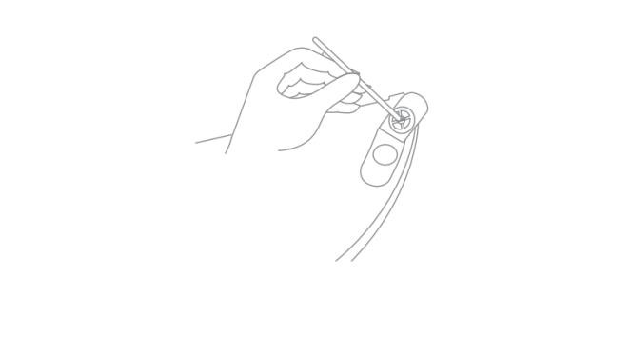

What should I do if the top cover of the water tank leaks?
The top cover of the water tank has a vent hole to balance the air pressure inside and outside the water tank. After filling water, level the water tank level during installation. Slight leakage is normal if the water tank is tilted during removing and installing.

Do I need to update the firmware whenever there is a new version released?
Each new firmware update is an optimization. Please update in time to ensure the best cleaning experience.

Why does D10 Plus start to clean the next zone before finishing the current one?
After the first mapping, Dreame D10 Plus will clean your home by room. If this issue occurs, check the zone settings in the app and adjust the settings if any errors arise.

Why does D10 Plus repeat its cleaning path?
Dreame D10 Plus will follow the most effective cleaning path to clean your home. It may look repetitive when the robot navigates itself from the cleaned area to an uncleaned one, but it is not repeating the work.

Can Dreame D10 Plus clean narrow spaces?
The minimum width for D10 Plus to pass through is 38 cm. Any spaces narrower than this number are not available for D10 Plus to clean.

Will the cleaning efficacy drop when cleaning a complicated environment?
The Dreame D10 Plus will clean all corners in your home to ensure complete coverage. D10 Plus turns to make more turns and vacuums along the edges in a complex environment, resulting in decreased efficiency.

How to reduce the noise during the cleaning?
Check if the brush is stuck with objects and clean it in time to avoid any damage caused.
To reduce the noise, kindly choose the quieter mode.

Why does D10 Plus make strange sounds during cleaning?
When cleaning on tile or wood floor, D10 Plus may produce a slight sound when its bottom rubs on the floor. The D10 Plus will clean and sweep the joins on the floor as it passes through, which may produce a slight rattling sound. These are all normal sounds and will not affect cleaning results.

What should I do if the Dreame D10 Plus is trapped during cleaning?
When cleaning, the D10 Plus may get stuck by slippers, plastic bags, and other clutters. Remove the clutters and put D10 Plus back to the cleaned area close to the interrupted point. Please clean up clutters on the floor to prevent the robot from getting stuck during cleaning.

What should I do if the Dreame D10 Plus gets stuck when trying to pass through some house furnishings?
During the Cleaning, if the robot meets the bottom of the furniture, which has a similar height to the robot, it may get stuck.
Please kindly purchase the magnetic stripes to avoid this issue. If not, please place some obstacles at the bottom of the furniture to prevent the robot from entering again.

What should I do if the side brush or main brush is entangled during cleaning?
When cleaning, the side brush and main brush may be entangled by power cords or charging cables on the floor.
Please try to place the host in the cleaned area nearby to continue cleaning after tidying up the cables.
Please clean up clutters on the floor to prevent the robot from tangling during cleaning.

What should I do if the Dreame D10 Plus is entangled with the power cable of the Base?
Please tie the excessive power cord of the Base with a strap before cleaning. Do not put it on the floor.

Why does the Dreame D10 Plus fail to relocate itself?
Moving the D10 Plus to an uncleaned area will cause repositioning failure. Ensure D10 Plus is moved to a cleaned area.
If a person is standing next to the D10 Plus, it will fail to reposition itself.
Do not stand next to D10 Plus and ensure the camera has full access to all feature points in the room.
D10 Plus may fail to reposition itself in low lights. Please ensure sufficient light for repositioning.

What is the max height of obstacles D10 Plus can cross?
The D10 Plus can cross obstacles up to 20mm high, shorter with the water tank installed. The max obstacle height will also decrease when D10 Plus is working on the slippery floor.

Why does D10 Plus fail to decelerate when meeting the obstacles?
With the LDS Sensor, the D10 Plus could detect the obstacles and decelerate.
However, for dark table legs or short barriers, it might be unable to detect and decelerate.

How to deal with device errors of the Dreame D10 Plus?
Press the Power/Clean button and hold for 6 seconds to reboot.

Why does D10 Plus fail to power on?
D10 Plus cannot be powered on in low battery. Please connect the D10 Plus to the Base and confirm the working temperature is in the range from 0 to 50℃.

Does D10 Plus consume any power when connected with the Base?
When connecting with the Base, the D10 Plus is powered by the Base, while the builtin battery of the D10 Plus will enter sleep mode with minimum power consumption to keep itself in the best performance.

Why does the D10 Plus fail to return for charging?
Check if there are too many obstacles around the Base. Please keep both sides of the base at least 0.5m away from the obstacles and make sure there are no obstacles 1.5m above the base.
1.If D10 Plus does not start from the Base for cleaning, it may fail to find the Base
2.after finishing up. Please ensure the Robot starts cleaning from the Base.
3.Moving D10 Plus to an uncleaned area will cause repositioning failure. In this case, restart the task.

Why does the robot keep connecting to the base after returning to charge?
Please check whether the charging interfaces of the base and the robot are with dust. Please clean the dust before using the system.

Why couldn’t I open the dust bin?
Please refer to the marking on the cover to open the dust bin correctly. Do not open the dust bin by removing the filter.

How to mop those stubborn stains on the floor?
The D10 Plus may not be able to remove some stubborn stains on the floor while mopping. Please clean them manually.

Why is the floor still dirty after mopping?
Wash the mop pad in time when mopping on the dirty floor.

Why do I fail to install the mop pad properly?
Align the mop pad with the module before installation.
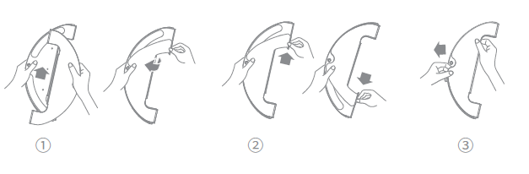

Why do I smell the odor from the mop and dust compartment?
Odor is caused by the dirty mop that is not washed in time after cleaning. Please clean the rag in time after mopping the floor. The dust bin may also emit odor with liquid getting inside. Please clean the dust bin in time after cleaning.

Why does the D10 Plus fail to do schedule clean?
It might be caused by the low battery level. The scheduled clean only works when the battery level is higher than 15%.

Why does D10 Plus fail to resume cleaning after recharging itself?
Make sure the D10 Plus is not working in the DND Mode. If you actively command it to return or manually move it back to the dock, D10 Plus will not resume cleaning either.

Why does the performance of D10 Plus fade with missed debris on the floor?
Clean the dust bin if it is full; Clean the filter clogged with dust; Clean the main brush if it is tangled with foreign matters.

Can D10 Plus operate in the low-light environment?
Yes, it could.

Why does the D10 Plus fail to upgrade the firmware?
Please kindly check the network connection and do the firmware upgrade with a stable network connection.
Please make sure the battery is over 15% before upgrading.

Why does Mi Home/Dreamehome App fail to load the cleaning data？
Check the network connection; Restart the app, and try again.

How to prevent the robot vacuum from cleaning the carpet?
Set the No-Go Zone around the carpet via the APP, and the robot vacuum will avoid the carpet while cleaning.

Why is the map different than before? What should I do if the map is distorted, inclined, or overlapped?
The map is distorted or overlapped:
Make sure the map is saved successfully, which means the parted sections are shown in the map, and the area cleaning can work properly.
Turn off the power and restart the robot vacuum. Then manually place the robot vacuum to the charging base and try to restore the map. If the restoration fails, replace the charging base position and redo the mapping.
Recommendations:
1.Properly place the base against the wall by making sure the open space beside the base should be at least 0.5m, and there are no obstacles 1m from the front of the base.
2.While the robot vacuum is working, please do not manually move the machine.
3.Strong light or highly reflective situations might cause the malfunction of the mapping.
4.We recommend closing the curtain or finding another time when the light is not so strong to clean. For highly reflective surfaces, it’s better to cover 15cm from the bottom of the surface while cleaning.
Users can reset the mapping, and the robot will remap during its next cleaning.
5. Regularly check and clean the navigation sensors with a soft cloth or tissue.

What should I do if the map configuration is not correct?
We could adjust the Map manually via the App.

Why is the Carpet Boost function unstable?
This function is still the beta version. Using the robot on the shorter carpet might cause the function failure.

What should I do if the robot vacuum fails to avoid obstacles during the cleaning?
1. Wipe the LDS sensor with a soft dry cloth and try to restart the device to check if it can work properly. The sensor might be clouded by dirt.
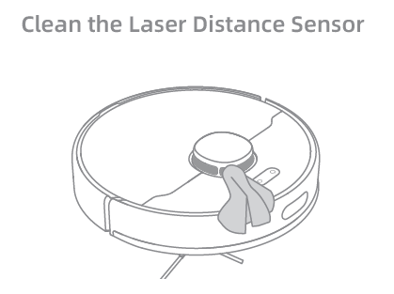
2.If the robot vacuum is connected to the network and is online, open the APP and click … on the upper right corner to check if the obstacle avoidance is off. Switch it on if it is off and restart the machine to check if it can work properly.
3.Make sure if the APP has the latest version. We suggest keeping the APP up to date ensure a better cleaning experience.

Why does the D10 Plus use a single-sided brush instead of a double-sided brush?
The D10 Plus uses a single-side brush + main brush for cleaning. The single-side brush is mainly responsible for cleaning the garbage near the walls and furniture edges. Compared with the double-sided brush, it is easy to blow up the garbage when cleaning, and the double-sided brush is more likely to be entangled on the carpet.

Can I use D10 Plus to clean carpets?
The D10 Plus can clean some medium and short-pile carpets. Carpets that are too long are more likely to be sucked into the dust box, and the side brushes and drive wheels are easy to get stuck. At the same time, it is recommended that you set up "sweeping restricted area"/"sweeping restricted area" to avoid wetting the carpet.

What should I do if the Dreame D10 Plus gets stuck when trying to pass through a narrow space?
D10 Plus may get stuck when it tries to clean a narrow space, for example, the bottom of a closet that is close to its height. Magnetic stripes are provided to help set a virtual wall or you can block the narrow space with an obstacle to prevent D10 Plus from entering.、

Why does D10 Plus fail to reposition itself？
Moving D10 Plus to an uncleaned area will cause repositioning failure. Ensure D10 Plus is moved to a cleaned area.
If a person is standing next to the D10 Plus, it will fail to reposition itself.
Do not stand next to D10 Plus and ensure the camera has full access to all feature points in the room.
D10 Plus may fail to reposition itself in low lights. Please ensure sufficient light for repositioning.

Why does the battery decrease rapidly during cleaning？
After D10 Plus is charged and stored for a long time, it is normal for the battery to drop quickly in the first few minutes during cleaning. After this, the power consumption will return to normal. The battery will also drop faster in Turbo mode.

Why does D10 Plus fail to return to the Base?
1.Check if there are too many obstacles around the Base. Put the Base in an open area free of obstacles within 0.5 m on both sides and 1.5 meters in front of the Base.
2.If D10 Plus does not start from the Base for cleaning, it may fail to find the Base after finishing up. Therefore, please ensure D10 Plus starts cleaning from the Base.
3.Moving D10 Plus to an uncleaned area will cause repositioning failure. In this case, restart the task.

How to adjust the humidity of the mop pod？
Launch the device via Mi home App and adjust the humidity of the mop pod in cleaning mode.

Why does the D10 Plus fail to avoid some obstacles？
To improve the cleaning performance, it is suggested to clean items such as threads/rags/slippers on the floor in advance.

Why does the robot fail to react when operating from the base？
When the robot is too far from the base, it will lose the connection. It will automatically connect back when the signal strength is stable.

Why does the robot turn off automatically？
The robot will turn off automatically when the battery is less than 2% or when it is not charging and has no operations in 12 hours.

Why does Mi Home/Dreamehome App indicates that the robot is offline？
Please make sure the robot is turned on and the Wi-Fi connection is stable. During the cleaning, the robot might be offline when the Wi-Fi network connection is weak in some areas. It will be back online automatically when the Wi-Fi signal is strong.

Why does the robot make a strange noise？
The main brush, side brush, or main wheels may be entangled with hair or debris. Turn off the robot and clean it.

